 | 
Laboratory 3: Integration of Sensors with ESP32 | School of Applied Digital Technology
Name:  Name: | ID:  ID: | Section:  Section:
Date: | Due date:

Objectives
- Connect multiple sensors (LDR, LED, PIR) to the ESP32 board.
- Write configuration in ESPHome to read sensor data and control the LED.
- Display sensor data on Home Assistant.
Experiment 1: Integration of Sensors with ESP32
Equipment:
 | Quantity
ESP32 | 1
MQ-2 | 1
Active Buzzer | 1

- Wiring the Sensors to the ESP Board
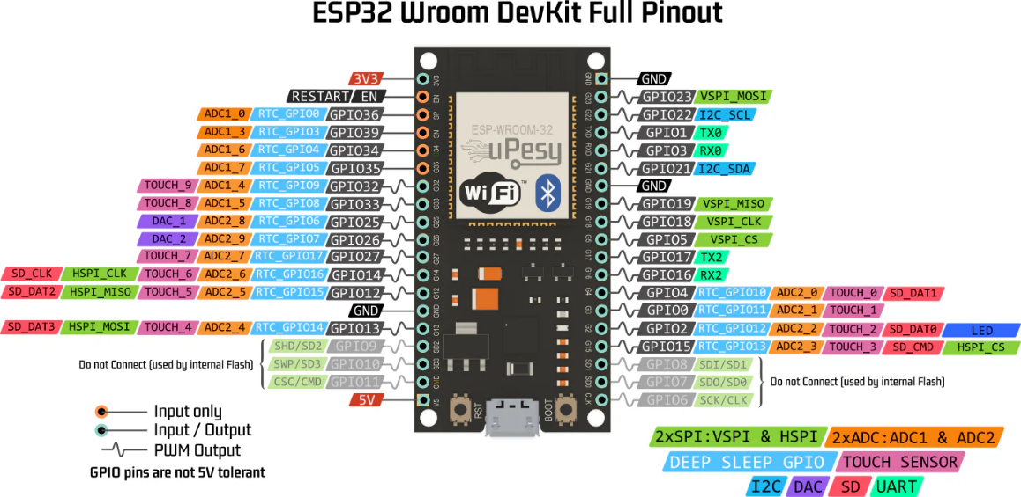

- MQ-2
  - VCC → 5V
  - GND → GND
  - A0 → GPIO34 (ADC input)
  - D0 → GPIO17 (digital input)
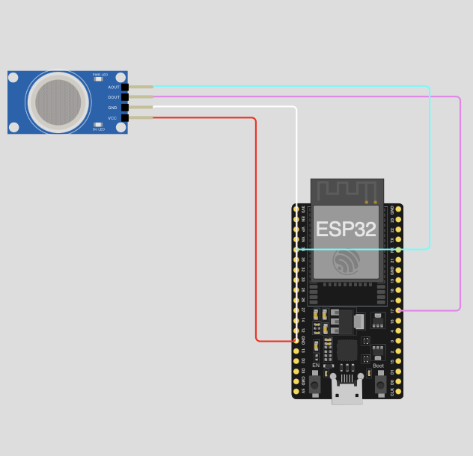
- Active Buzzer
  - VCC → VCC
  - AOUT → GPIO21
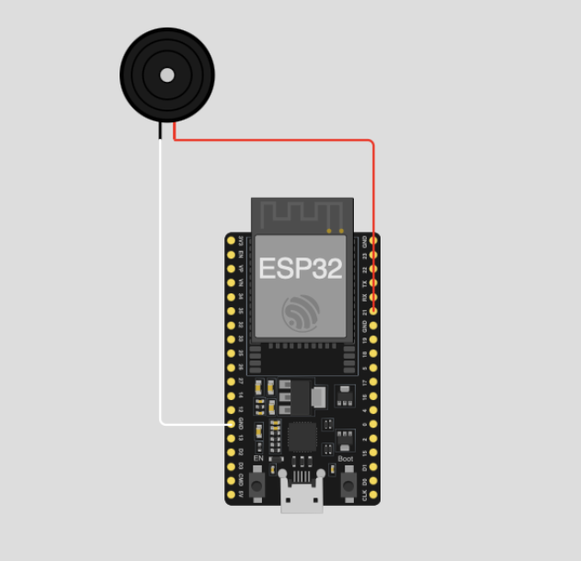
  - GND → GND

2. Open ESPHome and Select the Device
  - Go to the ESPHome Dashboard
  - Select your device (e.g., sensor)
  - Click EDIT to modify the YAML configuration

3. Add Code for the Sensors in the YAML File
Add the following to your configuration file:
- MQ-2
sensor:
- platform: adc
pin: GPIO34
name: "MQ-2 Gas Sensor Analog"
id: mq2_sensor
update_interval: 2s
attenuation: 12db
filters:
- multiply: 3.3

binary_sensor:
- platform: gpio
pin: GPIO17
name: "MQ-2 Gas Sensor Digital"
id: mq2_digital

Buzzer Module Active
output:
- platform: gpio
pin: GPIO21
id: buzzer_output
inverted: true

switch:
- platform: output
name: "Buzzer"
output: buzzer_output

4. Save and Install the Firmware
  - Click SAVE
  - Click INSTALL
  - Choose Wirelessly or USB depending on your setup
  - Wait for the upload to complete and let the device reboot

5. View Sensor Data in Home Assistant
  - Go to your Home Assistant Overview Dashboard
  - You should now see sensor readings such as:
• Gas Detection Level from MQ-2
• Buzzer Module Active

Take 1: Design and build a gas alarm system using MQ-2 sensors and buzzers.
Requirements:
1. Use an ESP32/ESP8266 board and an MQ-2 Gas Sensor.
2. Connect an Active Buzzer to indicate gas levels.
3. Read MQ-2 Analog values every 2 seconds.
4. Combine the sensor reading and buzzer control code into a single ESPHome YAML file.
5. Implement automation so the buzzer operates according to the following conditions:
• MQ-2 Analog ≥ 1.5V → Buzzer turns ON (alert)
• MQ-2 Analog < 1.5V → Buzzer turns OFF
6. Display MQ-2 Analog values (and optionally Digital output) in Home Assistant.

Continued on the next page.
CODE:

----- Have a good day -----
ANSWER:
# ---------- MQ-2 Analog ----------
sensor:
- platform: adc
pin: GPIO34
name: "MQ-2 Gas Sensor Analog" # ชื่อเต็ม
id: mq2_sensor
update_interval: 2s
attenuation: 12db
filters:
- multiply: 3.3 # แปลงค่าเป็นโวลต์

# ---------- Active Buzzer ----------
output:
- platform: gpio
pin: GPIO21
id: buzzer_output
inverted: true

switch:
- platform: output
name: "Active Buzzer"
output: buzzer_output

# ---------- Automation ----------
interval:
- interval: 1s
then:
- lambda: |-
const float threshold = 2; // กำหนดค่ามาตรฐาน
if (id(mq2_sensor).state > threshold) {
id(buzzer_output).turn_on(); // เกินค่า → ดัง
} else {
id(buzzer_output).turn_off(); // ไม่เกิน → เงียบ
}

